6GFM200 (12V200Ah)

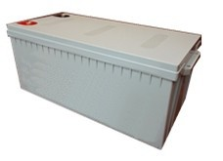
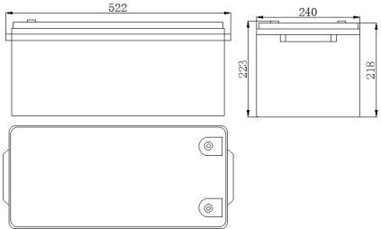
φ18
Speciﬁcations
Terminal Type
Nominal Voltage |  | 12V
Rated capacity |  | 200Ah
Dimensions | Total Height | 223±3 mm
 | Height | 218±3 mm
 | Length | 522±3 mm
 | Width | 240±3 mm
Weight Approx |  | 57.2±1.2 Kg

M8×18

F5
Number of Cycle (Times)
300 600 900 1200 1500 1800 2800 3100
0
40

20
15% D.O.D
30% D.O.D
100% 80% 50%
D.O.D D.O.D D.O.D
120

100

80

60
Capacity(%)

8.3

27.0

F8
25.5

Outer dimensions (mm)
Cycle Life 25℃(77℉)

Characteristics
Capacity 25℃(77℉) |  | 20 hour rate(10.9A) | 218.0Ah
 |  | 10 hour rate(20.0A) | 200.0Ah
 |  | 5 hour rate(34.0A) | 170.0Ah
 |  | 1 hour rate(113.0A) | 113.0Ah
Capacity affected  by Temperature (10 hour rate) |  | 40℃(104℉) | 102%
 |  | 25℃(77℉) | 100%
 |  | 0℃(32℉) | 85%
 |  | -15℃(5℉) | 65%
Self-Discharge at 25℃(77℉) |  | Capacity after 3 month storage | 91%
 |  | Capacity after 6 month storage | 82%
 |  | Capacity after 12 month storage | 64%
Charge (constant Voltage) | Cycle | Initial Charging Current less than 50.0A
 | Float | 13.5-13.8V

Discharge Curves 25℃(77℉)
0 1 2 4 6 8 10 20 40 60 2 4 6 8 10 20 40
(min) (h)
380A
220A
113A
34.0A 20.0A
13.8
13.2
12.6
12.0
11.4
10.8
10.2
9.60
9.00
8.40
7.80

Constant Current(Amp) and Constant Power(Watt) Discharge Table at 25 ℃(77℉)
Time |  | 10min | 30min | 1h | 2h | 3h | 4h | 5h | 8h | 10h | 20h
9.60V | A | 380 | 220 | 110 | 70 | 52 | 42 | 35.6 | 23.2 | 22 | 11.4
 | W | 3731 | 2120 | 1130 | 665 | 517 | 415 | 348 | 244 | 215 | 113
10.20V | A | 365 | 208 | 113 | 66.8 | 51 | 41 | 34.8 | 22.8 | 20.7 | 11.2
 | W | 3678 | 2062 | 1102 | 658 | 507 | 409 | 339 | 236 | 211 | 111
10.50V | A | 340 | 194 | 112 | 65.2 | 50 | 40 | 34 | 22.5 | 20.4 | 11.1
 | W | 3351 | 2020 | 1094 | 654 | 504 | 405 | 326 | 228 | 208 | 109
10.80V | A | 320 | 180 | 106 | 63.6 | 49 | 39 | 30.4 | 21.9 | 20 | 10.9
 | W | 3196 | 1886 | 1068 | 647 | 500 | 400 | 312 | 224 | 205 | 107
11.10V | A | 300 | 168 | 100 | 62 | 47 | 38 | 29 | 21.3 | 19.5 | 10.8
 | W | 3036 | 1707 | 1021 | 638 | 486 | 394 | 301 | 222 | 202 | 106

