1975x992x40 Module Technical Data
- Drawing of monocrystalline 380M72
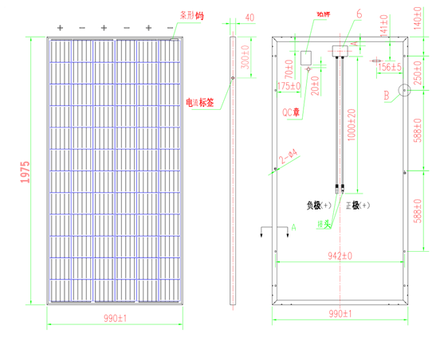

二、Technical parameters for modules：：
1、Monocrystalline -380M72
No. | Parts | Unit | Monocrystalline numerical value
1 | Module data | W | 380W
1.1 | Manufacturer/Model No. |  | Mono -380M72
1.2 | Peak power | W | 390
1.3 | Power tolerance | W | 0-5
1.4 | Module conversion efficiency | % | ≥19.7
1.5 | Open circuit voltage | V | 47.50
1.6 | Short circuit current | A | 11.04
1.7 | Operating voltage | V | 38.67
1.8 | Operating current | A | 9.85
1.9 | Series resistor | Ω | 0.5
1.10 | Filling factor | % | ≥75.00
1.11 | Module power temperature coefficient | %/K | -0.44
1.12 | Module voltage temperature coefficient | %/K | -0.33
1.13 | Module current temperature coefficient | %/K | 0.03
1.14 | Range of working temperature | ℃ | -40-85
1.15 | Working humidity | % | ≤95
1.16 | 2-year power degradation | % | ≤3.2
1.17 | 3-year power degradation | % | ≤3.9
1.18 | 4-year power degradation | % | ≤4.6
1.19 | 5-year power degradation | % | ≤5.3
1.20 | 10-year power degradation | % | ≤10
1.21 | 25-year power degradation | % | ≤20
1.22 | Hail impact resistance | m/s | 23.0
1.23 | Wind resistance | Pa | 2400
1.24 | Load | Pa | 5400
1.25 | PV module specification | mm | 1975x992x40
1.26 | Module weight | Kg | 22
1.27 | Max.System voltage | V | 1000
1.28 | Module service life | year | 25
2 | Glass data
2.1 | Glass type |  | Low iron suede ultra white tempered coated glass
2.2 | Glass thickness | mm | 3.2
2.3 | Transmittance | % | ＞91.5
3 | Cell data
3.1 | Cell voltage | Wp | ≥5.55
3.2 | Conversion ratio | % | ≥22.3
3.3 | Minority carrier lifetime | μs | ≥2
3.4 | Oxygen concentration | atoms/cm³ | ≤1×10¹⁸
3.5 | Carbon concentration | atoms/cm³ | ≤5×10¹⁷
3.6 | Cell size | mm | 158*158
4 | EVA data
4.1 | Density | g/cm² | ≥0.96
4.2 | Cross-linking degree | % | ≥80
4.3 | Tensile strength | MPa | ≥16
4.3 | Peel strength of glass | N/cm² | ≥60
4.4 | Peel strength of backboard | N/cm² | ≥40
5 | Backboard data
5.1 | Backboard structure type |  | Composite structure backboard
5.2 | Thickness | mm | 0.35
5.3 | Delamination peel strength | N/cm | ≥4
5.4 | Water vapor transmission | g/㎡d | ≤2
6 | Junction box data
6.1 | Max. load operating current | A | 15
6.2 | Max. Withstand voltage | V | 1000
6.3 | Service temperature | ℃ | -40-85
6.4 | Max. Working humidity | % | ≤95
6.5 | Protection degree |  | IP65 and above
6.6 | Cable specification φ | mm | 1x4mm² Length 1000mm

三、Module I-V diagream：
